Chapter 2, Solution 83

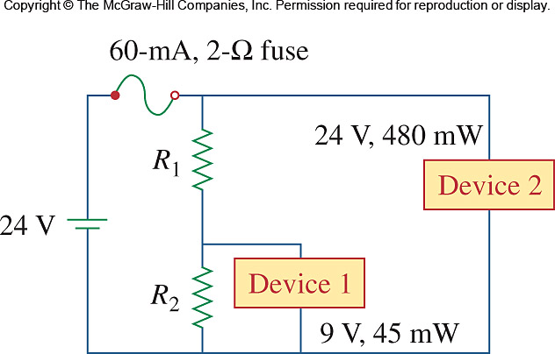
Two delicate devices are rated as shown in Fig. 2.142. Find the values of the resistors R₁ and R₂ needed to power the devices using a 24-V battery.

Figure 2.142
For Prob. 2.83.

Solution

The voltage across the fuse should be negligible when compared with 24 V (this can be checked later when we check to see if the fuse rating is exceeded in the final circuit). We can calculate the current through the devices.

I₁ =
I₂ =

R₁
-

+

24 V

R₂

i₁ = 5 mA

i₂ = 20 mA

i_{R1}
I_{fuse}

i_{R2}

Let R₃ represent the resistance of the first device, we can solve for its value from knowing the voltage across it and the current through it.

R₃ = 9/0.005 = 1,800 Ω

This is an interesting problem in that it essentially has two unknowns, R₁ and R₂ but only one condition that need to be met and that the voltage across R₃ must equal 9 volts. Since the circuit is powered by a battery we could choose the value of R₂ which draws the least current, R₂ = ∞. Thus, we can calculate the value of R₁ that give 9 volts across R₃.

9 = (24/(R₁ + 1800))1800 or R₁ = (24/9)1800 – 1800 = 3 kΩ

This value of R₁ means that we only have a total of 25 mA flowing out of the battery through the fuse which means it will not open and produces a voltage drop across it of 0.05V. This is indeed negligible when compared with the 24-volt source.

